

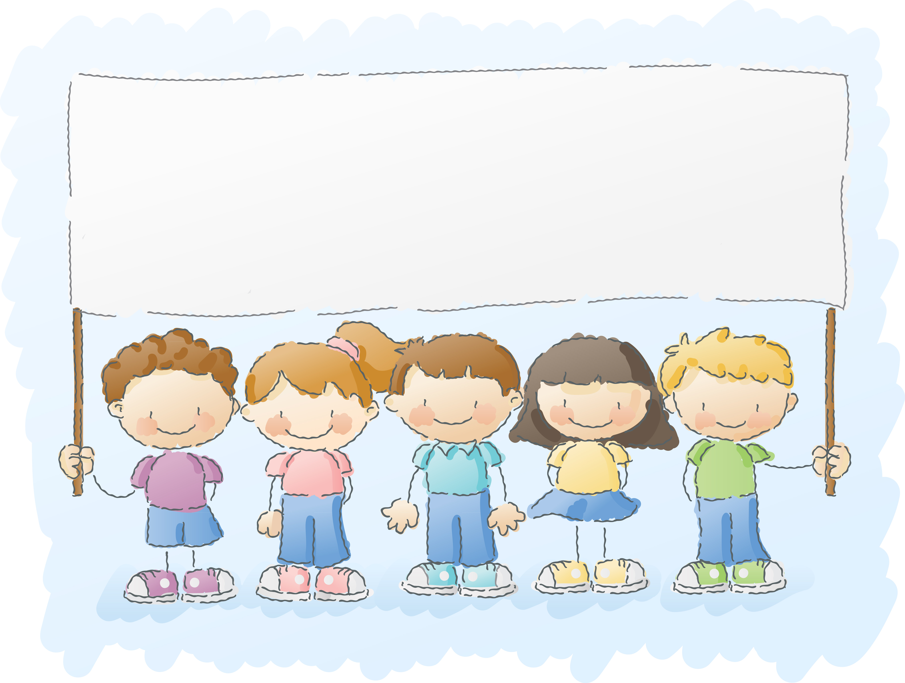

Join Our Team!

WordMasters Challenge™ is a great way to grow your vocabulary, learn how words are related, challenge yourself and have **fun**!

“I’ve had a blast doing WordMasters for the past three years.”

Jamie, 5th grade student

_____________________ _____________________ _____________________

_____________________ _____________________ _____________________

_____________________ _____________________ _____________________

_____________________ _____________________ _____________________

_____________________ _____________________ _____________________

_____________________ _____________________ _____________________

_____________________ _____________________ _____________________

_____________________ _____________________ _____________________

_____________________ _____________________ _____________________

_____________________ _____________________ _____________________

_____________________ _____________________ _____________________

_____________________ _____________________ _____________________