Dear Parents:

This year we will be participating in the WordMasters Challenge™. For nearly 40 years, WordMasters has been helping students:

- Expand their vocabulary
- Develop verbal reasoning and critical thinking skills through the use of analogies, and
- Most importantly, have fun!

“Thanks for the terrific year! My students discovered the power of words and
enjoyed adding so many to their vocabulary! We had a great time!”
–Ames Middle School

The WordMasters Challenge™ consists of three 20-minute analogy-solving meets held at school throughout the year (December, February and April). Prior to each meet, the students are given a list of 25 challenging vocabulary words that will appear in the Challenge Test analogies. Excellence in the competition will require both a mastery of the word meanings and thoughtful reasoning about the relationships between the words.

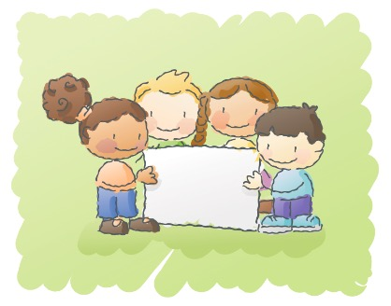
Ways to
Help

Join the Learning!

            - Help your child practice their words at home -- and learn some new words along the way!
            - Check out the Sample Word Lists and Analogies at our website (wordmasterschallenge.com) to see the format we use for Challenge tests.
            - Use the Study Tools posted under the Resources tab at our website, or check with your child’s teacher to see what other apps your child can use to study their words.

